Topology Qualifying Exam, January 2017

Problems
- Compute $H_{0}(X)$ where $X$ is shown in Figure 1.
- 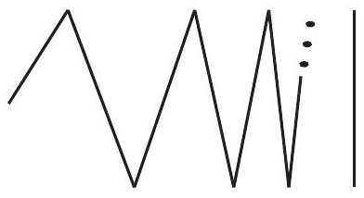
- Figure 1
- Let $Y$ be the annulus with identifications as shown in Figure 2.
  - Explain why $Y$ is a surface.
  - Is $Y$ orientable?
  - What surface is $Y$?
- 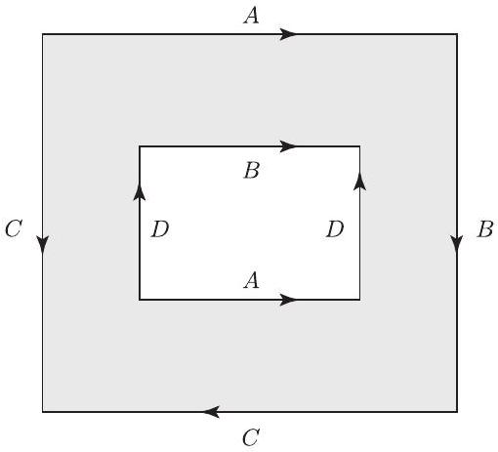
- Figure 2
- Show that $S^{1}×S^{1}$ is not the union of two disks (where there is no assumption that the disks intersect along their boundaries).
- Suppose that a continuous map $f:S^{3}×S^{3}→RP^{3}$ is not surjective. Prove that it is homotopic to a constant function.

  - Show that any finite index subgroup of a finitely generated free group is free. State clearly any facts you use about fundamental groups of graphs.
  - Prove that if $N$ is a nontrivial normal subgroup of infinite index in a finitely generated free group $F$, then $N$ is not finitely generated.
- Find all three-fold covers of the wedge of two copies of $RP^{2}$. Justify your answer.
- Let $X=S_{1}∪S_{2}⊂R^{3}$ be the union of two spheres of radius 2, one about $(1,0,0)$ and the other about $(-1,0,0)$, i.e. $S_{1}=\{(x,y,z)∣(x-1)^{2}+y^{2}+z^{2}=4\}$ and $S_{2}=\{(x,y,z)∣(x+1)^{2}+y^{2}+z^{2}=4\}$.
  - Give a description of $X$ as a CW complex.
  - Write out the cellular chain complex of $X$.
  - Calculate $H_{*}(X,Z)$.
- Use the circle along which the connected sum is performed and the Mayer-Vietoris long exact sequence to compute the homology of $RP^{2}\#RP^{2}$.
- Prove or disprove. Every map from $RP^{2}∨RP^{2}$ to itself has a fixed point.

